MILESTONE LIST

|  |  |  |  |  |  |  |  |
| --- | --- | --- | --- | --- | --- | --- | --- |
| Project Name | Emerging Methods For Early Detection Of Forest Fires | | | Date | 21/10/2022 | | |
| Project Domain | Artificial Intelligence | | | No of Members | 5 (HARI HARAN S, JEYA SHEELAN J, HEMANANTH  P, MOHAMED ANAS A, MOHAMED KATHAR MOHAIDEEN A) | | |
| Project Leader | Mohammed Kathar Mohaideen A | | | Project Owner/Client | IBM | | |
| Milestone Name |  | Milestone Number | Description Mandatory | | | | Optional |
| Project Objectives |  | M-001 | We will be able to learn to prepare dataset, image processing, working with CNN layers, read images using OpenCV and CNN for computer vision AI | | | Yes | - |
| Project Flow |  | M-002 | A project management process flowchart is a graphical aid, designed to visualize the sequence of steps to be followed throughout the project management process | | | Yes |  |
| Pre-Requisites |  | M-003 | To complete this project, we should have known following project such as Kera’s, Tensor flow, Python, Anaconda, OpenCV, Flask, Scikit-learn, etc. | | | Yes |  |
| Prior Knowledge |  | M-004 | One should have knowledge on the Supervised Learning, CNN and Regression Classification and Clustering, ANN | | | Yes |  |
| Data collection |  | M-005 | We can collect dataset from different open sources like kaggle.com, UCI machine learning etc | | | Yes |  |
| Image  Preprocessing |  | M-006 | Importing the Image Data Generator libraries, Define Parameters/Arguments for Image Data Generator class, Applying Image Data Generator Functionality to trainset and test set | | | Yes |  |
| Model Building |  | M-007 | Importing the model building libraries, Initializing the model, Adding CNN layers, Adding Dense layers, Configuring the learning Process, Train the model, Save the model, Predictions. | | | Yes |  |
| Video Analysis |  | M-008 | OpenCV for video processing, creating an account in Twilio service and sending alert message | | | Yes |  |
| Train CNN model |  | M-009 | Register for IBM Cloud and train Image Classification Model | | | Yes |  |

|  |  |  |  |  |
| --- | --- | --- | --- | --- |
| Ideation Phase | M-010 | Prepare Literature Survey on the selected Project and Information Gathering, empathy map and ideation | Yes |  |
| Project Design Phase-I | M-011 | Prepare Proposed solution, problem-solution fit and Solution Architecture | Yes |  |
| Project Design Phase-II | M-012 | Prepare Customer journey, functional requirements, Data flow diagram and Technology Architecture | Yes |  |
| Project Planning Phase | M-013 | Prepare Milestone list, Activity list and Sprint Delivery Plan | Yes |  |
| Project  Development Phase | M-014 | Project Development delivery of Sprint 1, Sprint 2, Sprint 3, Sprint 4 | Yes |  |

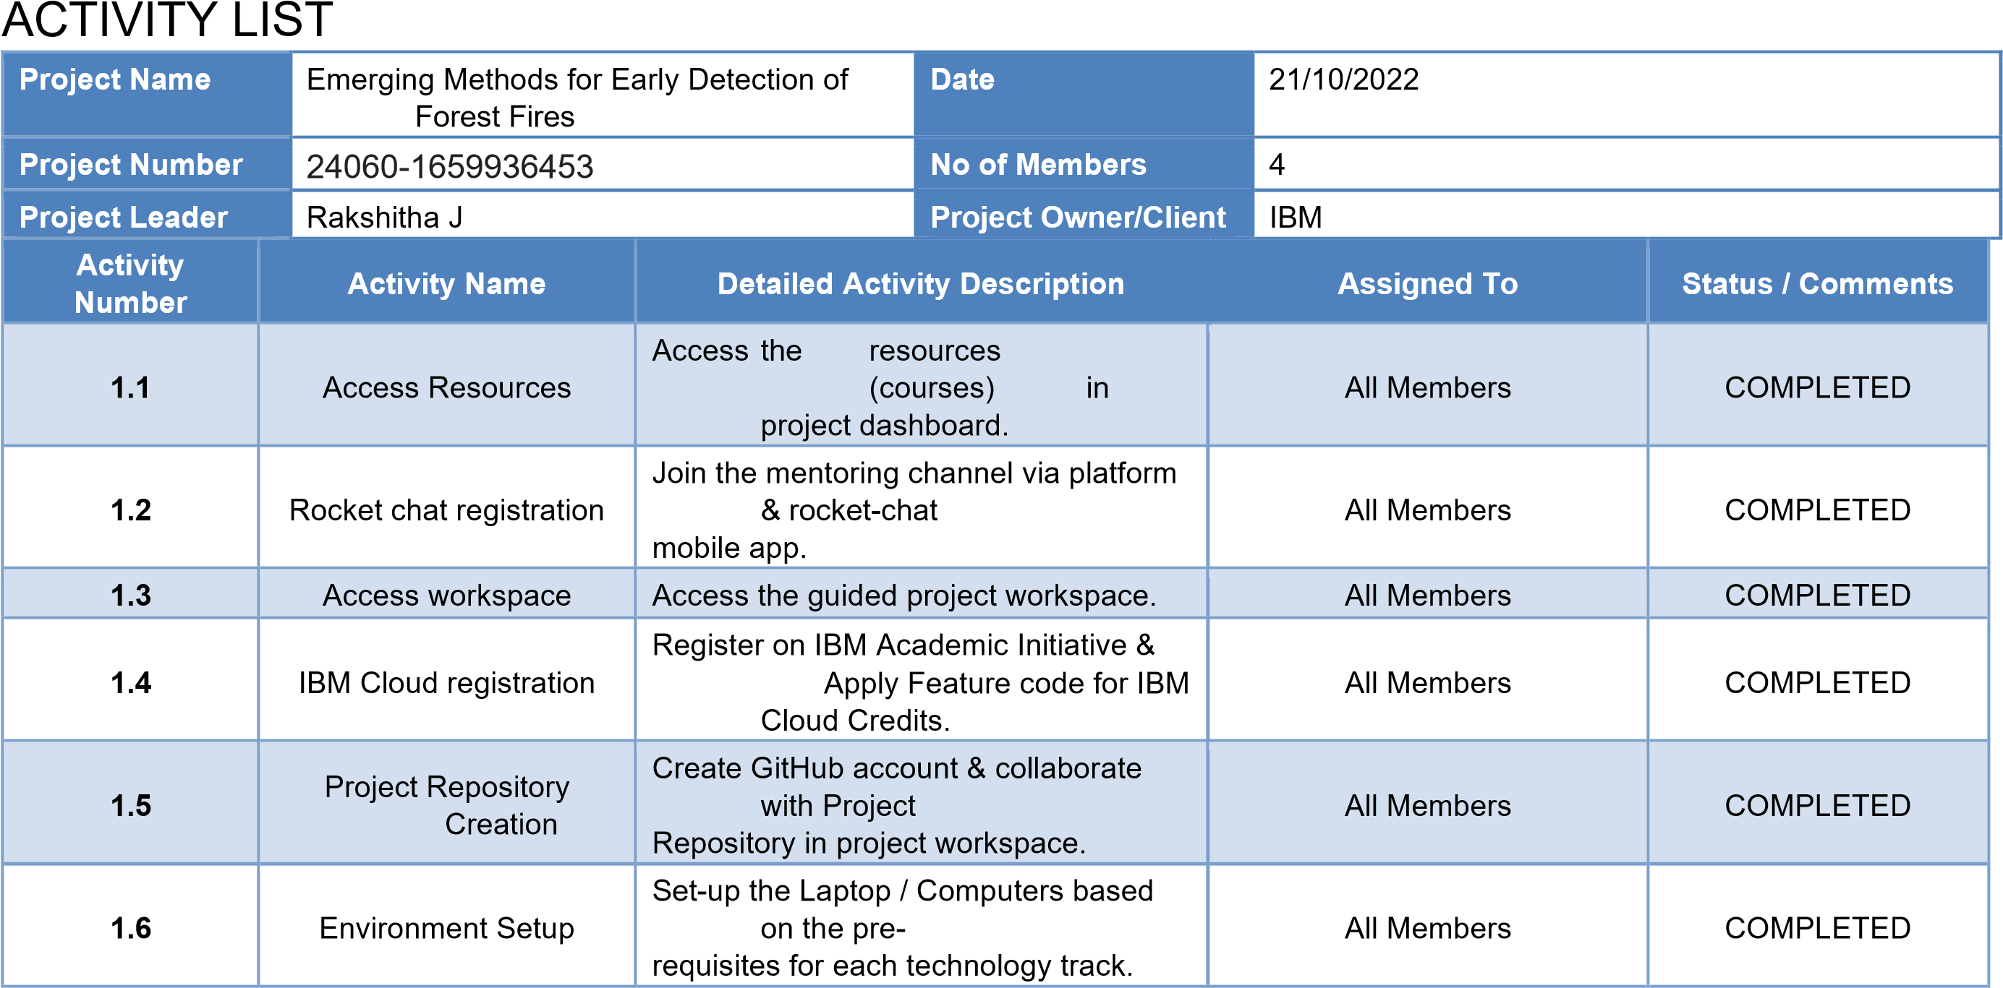

Mohammad kathar mphaideen A

|  |  |  |  |  |
| --- | --- | --- | --- | --- |
| **2.1** | Literature survey | Literature survey on the selected project  & Information Gathering. | Hemananth.P  Mohammad kathar mohaideen.A | COMPLETED |
| **2.2** | Technology Training | Attend the technology trainings as per the training Calendar. | All Members | COMPLETED |
| **2.3** | Empathy Map | Prepare Empathy Map Canvas to capture the user  Pains & Gains, Prepare list  of problem  statements | Hariharan S  Jeyasheelan j | COMPLETED |
| **2.4** | Technology Training | Attend the technology trainings as per the training Calendar. | All Members | COMPLETED |
| **2.5** | Brainstorming | List the ideas (at least 4 per each team member) by | All Members | COMPLETED |

|  |  |  |  |  |
| --- | --- | --- | --- | --- |
|  |  | organizing the brainstorming session and prioritize the  top 3 ideas based on the feasibility & importance. |  |  |
| **2.6** | Technology Training | Attend the technology trainings as per the training Calendar. | All Members | COMPLETED |
| **3.1** | Proposed Solution Document | Prepare the proposed solution  document, which includes the novelty, feasibility of idea, business model, social impact, scalability of solution, etc. | Mohamed anas A Jeyasheelan J | COMPLETED |
| **3.2** | Technology Training | Attend the technology trainings as per the training Calendar. | All Members | COMPLETED |
| **3.3** | Problem - Solution fit &  Solution  Architecture | Prepare problem - solution fit document  & Solution Architecture. | Mohamed anas A Jeyasheelan J | COMPLETED |
| **3.4** | Technology Training | Attend the technology trainings as per the training Calendar. | All Members | COMPLETED |
| **4.1** | Customer Journey Map | Prepare the customer journey maps to understand the user interactions & experiences with the application (entry to exit). | All Members | COMPLETED |
| **4.2** | Technology Training | Attend the technology trainings as per the training Calendar. | All Members | COMPLETED |
| **4.3** | Functional Requirements  &  Data Flow Diagrams | Prepare the Functional Requirement Document &  Data Flow Diagrams. | Hariharan S  Jeyasheelan j | IN PROGRESS |
| **4.4** | Technology Architecture | Prepare Technology Architecture of the solution. | Hemananth P | COMPLETED |
| **4.5** | Technology Training | Attend the technology trainings as per the training Calendar. | All Members | COMPLETED |
| **5.1** | Milestone  &  Activity List | Prepare Milestone &  Activity List. | Hemananth.P  Mohammad kathar mohaideen.A | COMPLETED |
| **5.2** | Sprint Delivery Plan | Prepare Sprint Delivery Plan. | Mohammad kathar mohaideen.A | IN PROGRESS |

|  |  |  |  |  |
| --- | --- | --- | --- | --- |
| **6** | Data Collection | Collect datasets from different open sources like kaggle.com, data.gov, UCI machine learning repository, etc. | Hariharan S  Jeyasheelan j | COMPLETED |
| **7.1** | Image Preprocessing | Importing the Image Data Generator Library | Mohamed anas A | IN PROGRESS |
| **7.2** | Image Preprocessing | Define the parameters/arguments for Image Data Generator class. | Mohamed anas A  Mohammad kathar mohaideen.A | IN PROGRESS |
| **7.3** | Image Preprocessing | Applying Image Data Generator functionality to trainset and test set. | Hariharan S | IN PROGRESS |
| **8.1** | Model Building | Importing the model building libraries. | Hemananth P | IN PROGRESS |
| **8.2** | Model Building | Initializing the model. | Mohammad kathar mohaideen.A | IN PROGRESS |
| **8.3** | Model Building | Adding CNN Layers. | Mohamed anas A | IN PROGRESS |
| **8.4** | Model Building | Adding Dense Layers | Jeyasheelan j | IN PROGRESS |
| **8.5** | Model Building | Configuring the learning process | Jeyasheelan j  Mohamed anas A | IN PROGRESS |
| **8.6** | Model Building | Training the Model | Mohammad kathar mohaideen.A  Hemananth P | IN PROGRESS |
| **8.7** | Model Building | Save the model | Mohamed anas A  Mohammad kathar mohaideen.A | IN PROGRESS |
| **8.8** | Model Building | Predictions | Mohamed anas A Jeyasheelan J | IN PROGRESS |
| **9.1** | Video Analysis | OpenCV for video processing. | Hariharan S  Jeyasheelan j | IN PROGRESS |
| **9.2** | Video Analysis | Creating an account in Twilio service. | Hemananth.P  Mohammad kathar mohaideen.A | IN PROGRESS |
| **9.3** | Video Analysis | Sending alert message. | Hemananth.P  Mohammad kathar mohaideen.A | IN PROGRESS |
| **10.1** | Train CNN Model on IBM | Register for IBM Cloud | All Members | IN PROGRESS |
| **10.2** | Train CNN Model on IBM | Train Image Classification Model | All Members | IN PROGRESS |